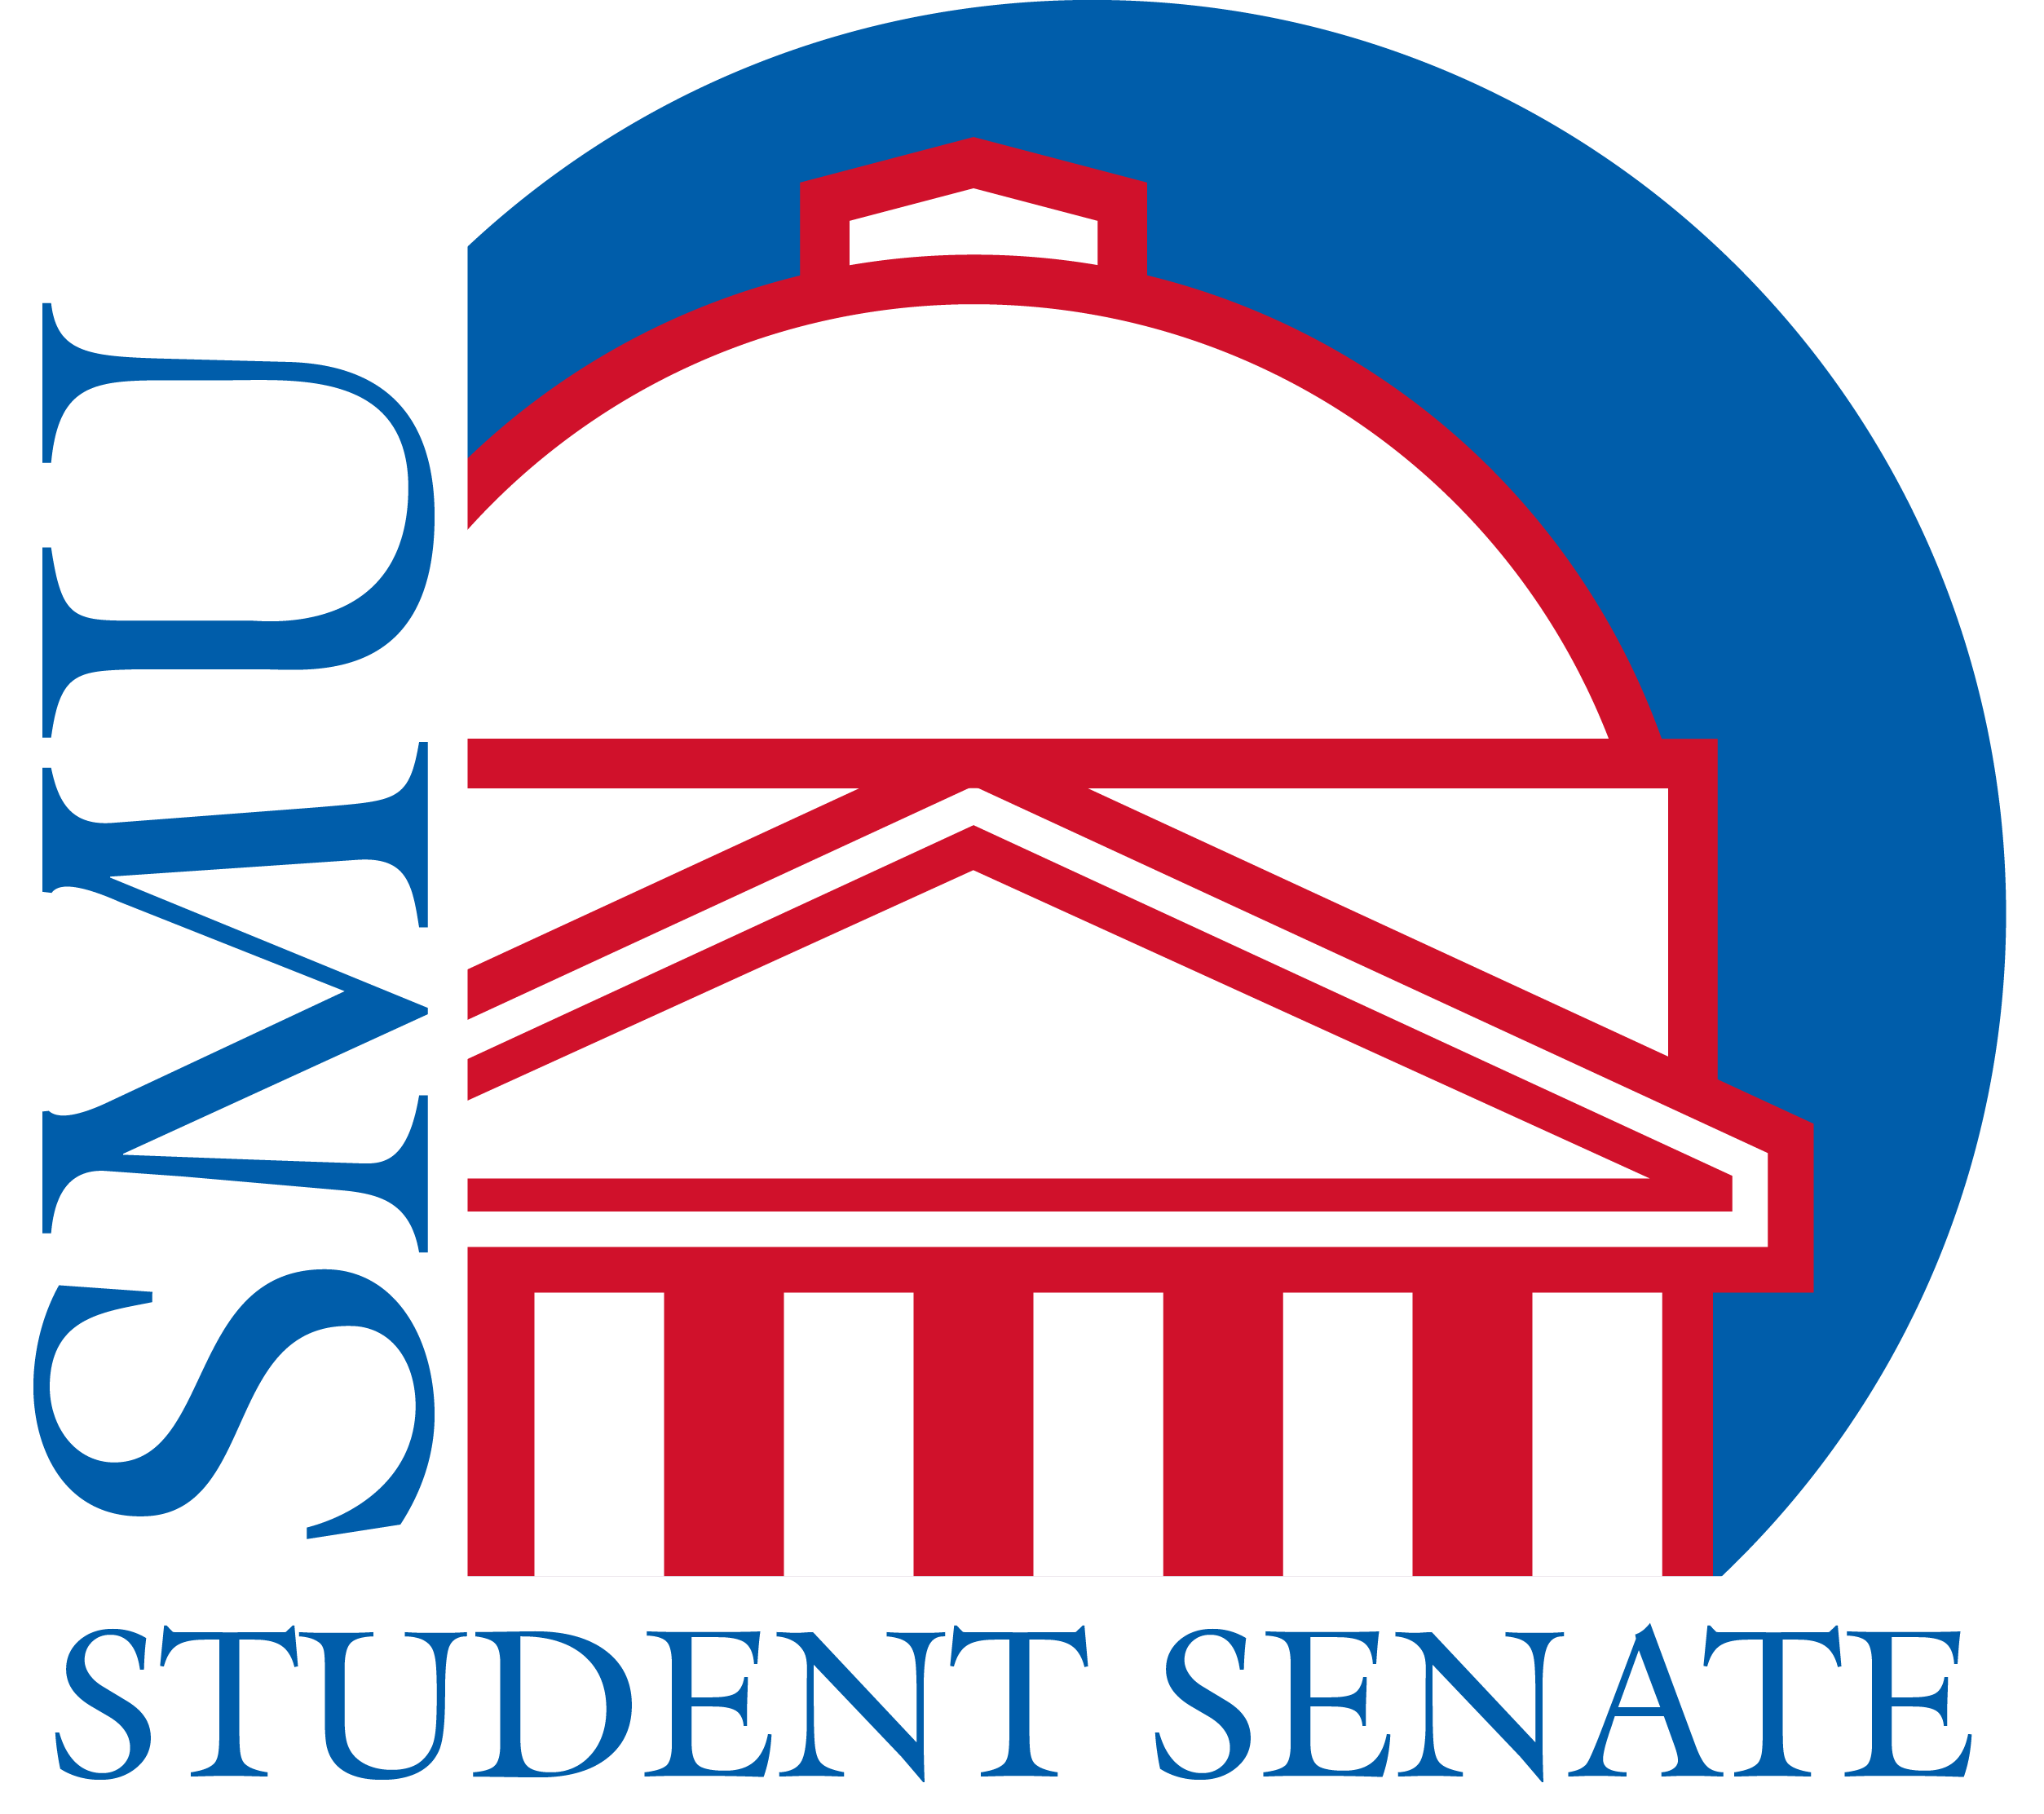

SMU STUDENT SENATE

Legislative Number: S-103-04 Final Vote:

Author(s): Arthur Troy, Ben Ovenshire, Davis Wells Senate Secretary: Davis Wells

Dean of Student Life: Dr. Joanne Vogel Student Senate Chair: Matthew Lucci

A RESOLUTION CALLING FOR INCREASED ACCOUNTABILITY AND COMMUNICATION FROM THE OFFICE OF FACILITIES MANAGEMENT AND PLANNING

WHEREAS There is a significant disconnect between the SMU office of facilities management and the student population they serve, multiple instances have occurred over the previous two semesters that exemplify the lack of communication and accountability that has become almost expected by the students. Most recently and publicly there have been two power outages that have greatly disrupted classes and other operations on campus, in both cases a reasonable explanation or apology was not provided;
RECOGNIZING That the punctuated instances such as power outages, water damage, and closures are not isolated in the concerns of the student body and their elected representatives, the office of facilities management pursues operations and strategy with apparent disregard to the impact on student life; as such SMU is rather unique in their outsourcing strategies, in 2015 more than $15 million went to our, at the time, food and facilities contract with Aramark corporation; since that time the facilities portion of that contract has been renegotiated with GCA Services Group for an undisclosed sum, this process occurred with no student input or transparency of any kind; as it stands, facilities and custodial concerns are one of the largest complaints of both students and faculty, the managing office for such operations currently has no means of accountability or conduit to connect to students; When Aramark managed the facilities, individuals had the opportunity to contact an "on-call personnel" number, this individual would be local and attend to emergency facilities concerns 24/7; with no notification of change, the number now redirects to a call center in San Diego, nearly 1,400 miles away, the call center then takes note of the concern to be handled on the next business day, so far this year there have been countless examples of health and bio-hazard scenarios that have not been handled appropriately because the mechanisms to report such emergency concerns have been dismantled without notice or explanation; additional health concerns that have continued without comment or apparent concern from the office of facilities management include but are in no way limited to buildings shuttered because of asbestos contamination, gas leaks, flooding, and dangerous mold in residential facilities;
ACKNOWLEDGING that the office of facilities management works diligently to make possible the beautiful buildings and grounds for which this University has come to be known, and that the facilities office cannot be expected to plan for every possible issue that might arise, increasing the level of consideration beyond simply aesthetic and towards strategic functional concerns would be highly beneficial in supporting and protecting the SMU community; additionally, there have been multiple positive interactions between the office of facilities management and the SMU Student Senate body, for which the authors acknowledge and are grateful;
BE IT THEREFORE
RESOLVED It is the call of this body for the strategies and operations of the office of facilities management and planning to be reviewed such that said office may better communicate and serve the community in their mission; as such, we recommend the following actions: Emphasize the importance of communication by taking time once a semester to update student stakeholders on issues and initiatives that have been identified and are being pursued by the SMU office of Facilities; review the process by which maintenance and custodial concerns are reviewed, the current process is neither transparent nor does it provide any personal accountability, supplementally outlining ongoing concerns and projects with periodic progress reports to a central online information page; the establishment and publication of a clear and reliable facilities on-call protocol so that campus staff, such as Residential Assistants, Residential Commons Directors, Professors, etc. are able to confidently request help in the event of a facilities emergency, additionally to reinstitute the 24/7 on call facilities contact such that the community may avoid or prevent instances that actively damage campus buildings or threatening student health or safety.

Respectfully Submitted,

Ben and Arthur
Position

