Minutes of the 105th SMU Student Senate
February 12, 2019

Regular Meeting – Hughes - Trigg Forum

- Call to Order
- Values Statement
  - I, as a citizen of the SMU community, commit myself to upholding the values of intellectual integrity, academic honesty, personal responsibility, and sincere regard and respect for all SMU students, faculty, and staff.
- Moment of Silence
- First Roll Call
- Approval of the Minutes
- Approval of the Agenda
- Speaker’s Podium
- Reports of the Committees with New or Old Business
  - Finance Committee
  - Organizations Committee
- New Business
- Old Business
- Senatorial Forum
- Collaboration Group Time (15 Minutes)
- Officer Reports
- Reports of the Senate Advisors
- Committee Reports
- Announcements
- Second Roll Call
- Adjournment

Written Reports of the Officers
Nathan DeVera, President
Hello hello! You all are my Valentines this week <3

Dean of Students Search
As you all know, our University has spent the past 2 weeks going through a search for a permanent Dean of Students. All 4 candidates interviewed and presented, and now Dr. Mmeje will be making the final decision very soon (if he has not decided already). Stay tuned!

CIO Student Advisory Board Update
- *Yield time to Senator Momin Irfan*
- "Duo" dual authentication will be required for all students' my.SMU starting April 1 (no joke)
- Hackathon Debrief (Momin)
- Summer 2019 will bring classroom upgrades, technology-wise
- Microsoft Team (similar to slack) will be joining Office 365 package
- NSSE Survey Tile on my.SMU for Freshmen & Seniors
- Smart phones as student IDs in the future of SMU technology?
- Canvas utilization up on both the student and professor ends!

Upcoming Meetings
- NONE THIS WEEK

Keep working hard! I cannot stress how important our role is for the improvement of the SMU community. Always feel free to reach out if you need anything from me!
- Your Friendly Neighborhood SBP

Victor Sanchez, Vice President
-Had several interviews with Lexi on Monday to fill vacancies
-I want to decrease the number of Senators and increase the number of constituents that each Senator represents
-Therefore, I have to change the Constitution. In the works. Thoughts?
-Increase President's Discretionary fund legislation. In the works.

Darian Taylor, Secretary
No report submitted.

Kathy Hines, Graduate Affairs Officer
“Nothing new from my committee,”

Ben Prengler, Speaker
Good afternoon everyone! MANY developments to discuss. See below:

2019 Boulevard Discussions: Today I met with Noelle Kendall, the rep to the Board of Trustees for athletics. If I have updates, I will let y’all know.

The Parking Issue: I am restarting the Parking Task Force Collab Group, so join if you’re interested. We will take on the Cox Grad Student issue from before and will meet with Mark Rhodes in the next two weeks.

Senate On-Boarding: Yes, we will have another on-boarding session when the new Senators arrive. So, if you’re interested in a little parliamentary refresher, then come by. Time and date TBD.

New Report Guidelines: After our discussion two weeks ago about how to make Senate more efficient and enjoyable, I sent out a list of guidelines to all Officer and Chairs. In total there are six, but the main point is: if you can put your report as a written report, then there is no need to have an oral report, it just takes up time. I hope all chairs and officers adhere to this or else there may be legislation on the horizon.

Legislation Deadline: Wednesday at 11:00 am.

That’s all for me! Thanks!

Greta Felten, Chief of Staff
This week, I began to work with the committees to ensure that all of our Senate committees will have a full roster and solid plan for the semester. Once we fill chamber with our new senators, all Senators will be assigned to a committee if they are not already in one.

I have yet to hear back from Molly Patrick, Turner Hinrichs, Christian Parker, and Ben Horton about the status of their committee roster and activities.

Please reach out to me if you are a Senator and not on a committee currently, or if your current committee meeting does not fit in your schedule. And, keep encouraging others to apply to be Senators and General Members!

I'm so excited to get to work with all of you this semester. Have a great week!

Zach Kosub, Parliamentarian
No report submitted.

Written Reports of the Senate Advisors

Jennifer (JJ) Jones, Senate Advisor
No report submitted.

Dawn Norris, Senate Advisor
· Hilltop Excellence Awards – nominate deserving students, faculty and staff before 2/18 @ 7 am on Connect. Any member of the SMU community can submit a nomination.
· How to get a YES when you ask for a recommendation.

Written Reports of the Committees:

Molly Patrick, Student Concerns Chair
Our speaker comes next week! Please sign up to be an ambassador to volunteer from 12-2 for some Senate Representation.

Self defense class is Thursday, February 28th at 6:30! Can’t wait to see y’all there!

Zach Kosub, Internal Affairs Chair
No report submitted.

Megan Janus, Communications Chair
We are taking a group photo next week, Feb. 19th, at 4:00 during Chamber. Please dress nice!

Naomi Samuel, Diversity and Inclusion Chair
Diversity & Inclusion week is still April 1st-5th. Multicultural Greek Council showcase is this Wednesday at 7 in the theatre!

Christian Parker, Endowment Chair
Nothing new from me.

Benjamin Horton, Finance Chair
New Business
Date of Request | Time | Organization | Vote | Amount Requested | Amount Allocated | Name | Email
2/10/2019 | 3:40 | Full-Time MBA Student Advisory Board | 4-0-0 | $6,000 | $3,000 | Sailesh Ramanathan | sramanathan@smu.edu
2/10/2019 | 3:50 | SMU Cox Rugby Club | 4-0-0 | $14,819 | $13,500 | Matt Miller | matthewms@smu.edu
2/10/2019 | 3:55 | Vogel-Wise Lab, SMU Biology Department | 4-0-0 | $6,150 | $4,550 | Kasi Holcomb-Webb | kholcombwebb@smu.edu
2/10/2019 | 4:05 | Dedman School of Law SBA & Cox School of Business SAB | 4-0-0 | $10,000 | $5,000 | Brooke Adams (President of SBA) | pbadams@smu.edu
2/10/2019 | 4:10 | Minority Association of Pre-Health Students | 4-0-0 | $250 | $250 | Josselyne Orbegoso | jorbegoso@smu.edu
2/10/2019 | 4:15 | N/A (Individual Request) | 4-0-0 | $2,610 | $2,290 | Tannah Oppliger & Lamisa Mustafa | toppliger@smu.edu
2/10/2019 | After | Indian Student Association | 3-2-0 | $3,622 | $3,622 | Kerman Ahluwalia | kahluwalia@smu.edu

Old Business
Request | Organization |  |  |  | Vote |  | Amount Requested |  | Amount Allocated |  | Name |  | Email
2/3/2019 | SMU Naturals |  |  |  | 4-0 |  | $701 |  | $699 |  | Alexa Clinton |  | lclinton@smu.edu
2/3/2019 | SMU Naturals |  |  |  | 4-0 |  | $192 |  | $183 |  | Alexa Clinton |  | lclinton@smu.edu
2/3/2019 | SMU Naturals |  |  |  | 4-0 |  | $139 |  | $117 |  | Alexa Clinton |  | lclinton@smu.edu
2/3/2019 | SMU Dedman School of Law Sports & Entertainment Law Association |  |  |  | 4-0 |  | $1,850 |  | $1,420 |  | James Harper |  | jbharper@smu.edu
2/3/2019 | Theta Tau |  |  |  | 4-0 |  | $1,314 |  | tabled |  | Tyler Westerhoff |  | twesterhoff@smu.edu
2/3/2019 | SMU Hip Hop Club |  |  |  | 4-0 |  | $1,410 |  | $930 |  | Abby Gwin |  | agwin@smu.edu
2/3/2019 | Student Leadership Initiative |  |  |  | 4-0 |  | $1,975 |  | $1,975 |  | Cydney Snyder |  | cksnyder@smu.edu
2/3/2019 | SMU Asian Council |  |  |  | 4-0 |  | $600 |  | $600 |  | Manqi Shi |  | manqis@smu.edu
2/3/2019 | Association of Black Students |  |  |  | 4-0 |  | $300 |  | $300 |  | Darriana Druery |  | ddruery@smu.edu

Turner Hinrichs, Investments Chair
The Investment Committee has decided on dates for our Spring pitch cycles and is currently dividing up into pitch groups. Our first round of pitches will take place on February 28th. Additionally, our faculty have approved 4 sell transactions (per analysts' recommendations) which will be processed this week. To review our analysts' recommendations, please view our "Portfolio Holdings and Recommendations" document in Box.

Alexa Clinton, Membership Chair
No report submitted.

Chris Earles, Organizations Chair
New Business
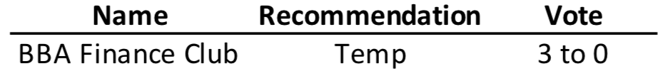
Old Business
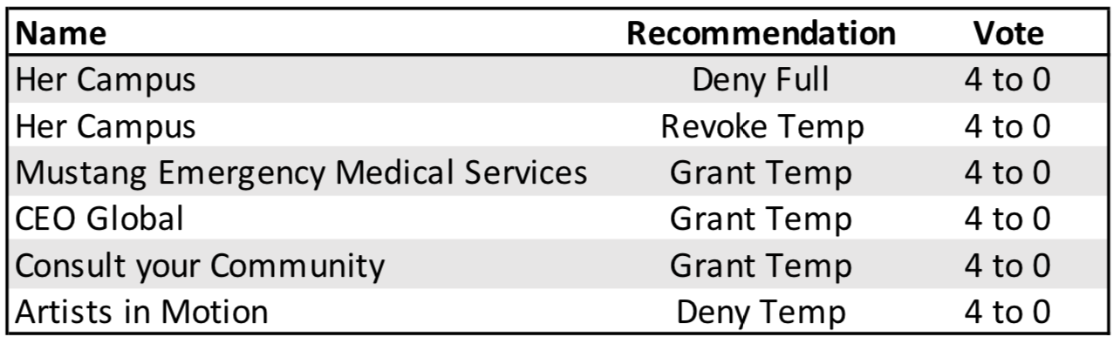

VACANT, Scholarship Chair
No report submitted.

Minutes:

- Unanimous Consent of Agenda
- Committees w/ New or Old Business:
  - Finance:
    - New Business: A lot of graduate groups (MBA Gala, Cox Ruby Group, Vogel Wise Lab Biology Department, etc.)
      - No questions
    - Old Business: SMU Naturals, Contract Negotiation
      - No questions
      - Sanchez: Motion to see old business in block - approved
      - Sanchez: Motion to approve old business in block - approved
  - Orgs:
    - New Business: BBA Finance Club
      - No questions
    - Old Business:
      - Her Campus - no to full charter and revoke temp charter
        - Pittman: If Her Campus shouldn’t have a charter, why did they apply?
          - When they came in, they said the reason they were interested was because they wanted to continue being the only SMU forum on campus that would be free from SMU’s grip. They didn’t mention that they want an Senate Semester Budget, etc.
        - Urbina: Do you send your decision as a committee to the right person?
          - Yes, we have been keeping contact with their President .
        - Urbina: Understanding this is a recommendation from the Committee to the Chamber, in that email, do you send them a recommendation to follow up and then address us?
          - When we voted as a committee to revoke their charter, there were no stipulation with charter ship.
        - Pittman: What are the consequences of approving them/what is the downside?
          - If we approve them for the full charter, they no longer have direct over sight of the Orgs. Committee
      - Enslin: Motion to see old business in block - approved
      - Enslin: Motion to approve old business in block - approved
- Reports of Officers:
  - President Devera: OIT Report
    - Yield time to Irfan
      - Updates to Tech: Duo Login is coming on April 1st, Researching and bringing phone IDs, pilot tech spaces and we want to bring those to residence halls, computer labs and technologies
      - Hackathon Debrief
    - Questions:
      - Anastasi: Where is the Pilot for for this tech?
        - In Cox, you can tour soon
  - VP Sanchez:
    - We are going to have more Senators soon
    - Chamber number: I think that there are too many seats in Senate. Reducing the number of Senators will increase competition, increase efficiency, reducing turnover, etc.
    - Questions:
      - Urbina: The numbers that you gave us is it that the number of Senators
      - Hines: Is the number that you’re going to propose going to be based on an average or projected number?
      - Enslin: For first year Senators, would you be opposed to keeping the current election structure?
      - Hinrichs: What is your assumption behind the belief that one senator for 500 is any different than one senator for 300?
      - Clinton: If this passes, when would this go into affect?
      - Jain: What would happen to someone if they are already a senator, but it is too competitive?
      - Urbina: What is the main reason you are proposing these changes to the constitution?
      - Hines: Have you considered to potential distraction this would cause there to be less graduate senators in chamber?
      - Waken: Retention vs being too many people already?
      - Waken: Is this just because we had so many people leave this semester or have you seen this over the year?
      - Urbina: Is there another way to resolve these problems?
  - Sec. Taylor
    - No report
  - Speaker:
    - Questions:
      - Whitaker: Will your parking task force answer other parking questions as well?
      - Hines: Did you know that o Monday, I was in a meeting with Dr. Mmeje

