110th Student Senate Meeting Minutes 11/14/2023

In Attendance: 110th Student Senate Chamber, Advisory Murphy, Dr. Mmeje, Title IX coordinator Jasper, Registrar Lothringer, Dr. Samantha Thomas, Student Trustee Hererra
- Roll Call
- Approval of the agenda
  - Approved
- Speakers Podium - Dr. Mmeje and Registrar Lothringer
  - Expanded Demographic and Identity Data Collection
    - Senate initiative 3 and a half years ago
  - 2022 PEC approved to allow preferred name on diploma
  - 2022 PEC charges university to develop proposal for expanded data collection
  - October 2023 proposal submitted to PEC and it was approved
  - Allows students to choose gender identity and preferred pronouns
  - This is all voluntary
  - Added additional options for ethnicity and race
- Speakers Podium - Dr. Samantha Thomas and Jasper Cheng
  - Title IX coordinator
  - 2020 major overall of sexual harassment policy
  - Grievance procedures changes with cross examination change
  - All information found under Policy 3.1 Sexual Harassment, Non Title, Grievance Process and 3.3.
  - 3.3 is used if happened at university, 3.1 is if something happens outside of the SMU community
- Finance Committee New Business 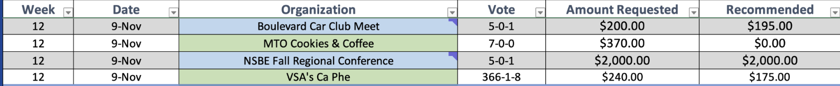
  - Motion to see the new business as read
    - Approved
- Finance Committee Old Business
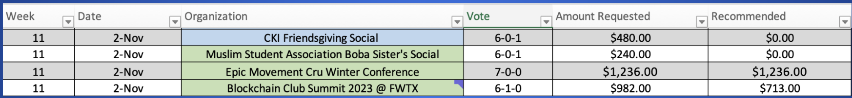
  - Motion to see old business as block
    - Approved
  - Motion to approve
    - Approved
- Finance Budget Retreat update
    - $953,799 requested
    - $150,000 budgeted
- Orgs New Business
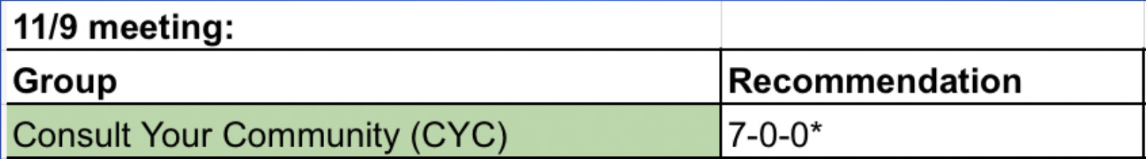
  - Motion to see as old business
    - Approved with 1 opposed
- Orgs Old Business
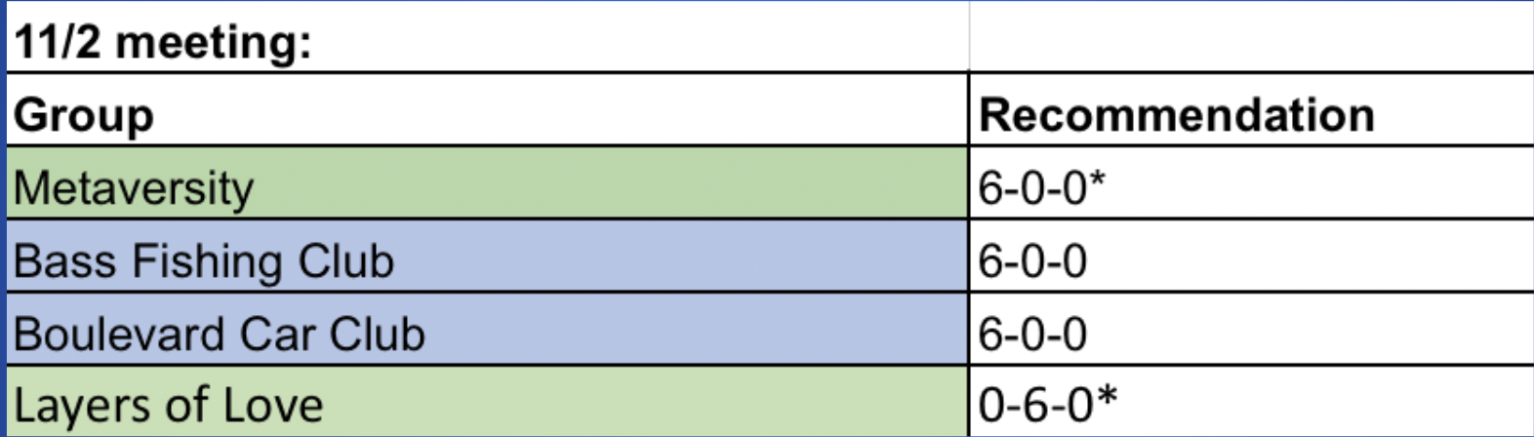
  - Recommended to approve all the following
  - Motion to see old business in block
    - Approved
  - Motion to approve in block
    - Approved
- Officer Report - President
  - Yield time to Rabbi Coretz
  - Tuesday at 5 till sunday at noon
  - Friday at 5 for shabbat
- Officer Report - Vice President
- Membership Chair Lugo
  - SBO candidates required to have been in the chamber the year prior
    - Motion call to question
      - Approved
    - Senator Horn for
    - Senator Thomas against
    - Senator Hill for
    - Senator Pilla against
    - Senator Horn asked for President Alarcon opinion
    - President Alarcon
    - Vote: 25-17-3
      - approved
  - Running mate conversation: President and VP
    - Senator Horn: For
    - Senator Thomas: Against
    - Vice President Bombito: Against
    - Motion call to question
      - Approved 1 against
    - Vote: 23-20-2
      - Approved
  - No monetary compensation or items of value for campaign favors
    - Motion call to question
      - Approved
    - Speaker for senator Thomas
    - Vote: 41-3-1
      - Approved
  - Clarification that candidates are responsible for the actions of their campaign representatives
    - Motion call to question
      - Approved
    - Senator thomas for
    - Vice President Bombito against
    - Senator Thomas rebuttal
    - Motion by hand raise
      - 44-1-0
    - Vote: 30-8-6
      - Approved
  - Vacancy Specifics: Application screening process, rubric, DEI committee chair given discretion to appoint an interviewer for special interest roles
    - Motion call to question
      - Approved
    - Senator Pilla for
    - Senator Hill against
    - Vice President Bombito for
    - Senator Thomas against
    - Motion call to question
      - Approved
    - Vote: 30-6-7
      - Approved
    - Motion to reconsider
      - Approved
    - Motion to table
      - Approved
  - 72 hours to remove campaign materials
  - Streamlined requirements of who can run and vote for Asian Pacific Islander, First Gen and International Senator.
- Officer Report - Parliamentarian Leathers
- Advisor Report
- Announcements
- Adjournment

