110th Student Senate Meeting Minutes 11/7/2023

In Attendance: 110th Student Senate Chamber, Dean Sutton, Advisory Murphy
- Roll Call
- Approval of the agenda
  - Approved
- Finance Committee New Business 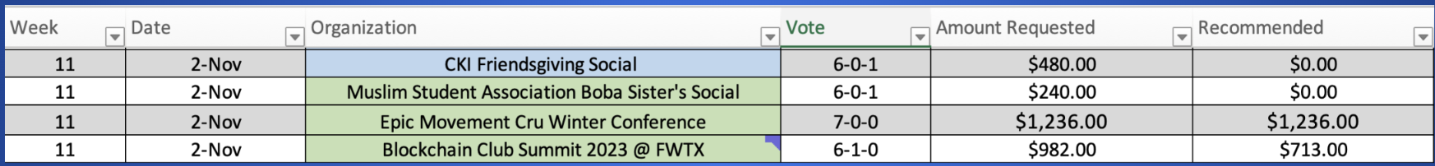
  - Motion to see the new business as read
    - Approved
- Finance Committee Old Business 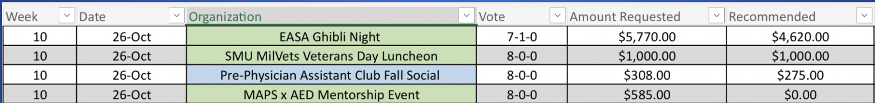

  - Motion to see old business as block
    - Approved
  - Motion to approve
    - Approved with 1 abstention
- Orgs New Business
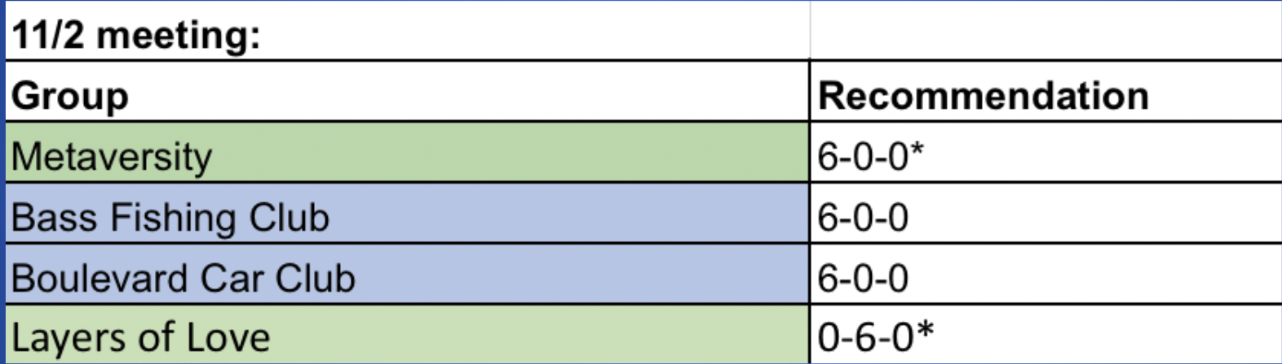
  - Motion to see as read
    - Approved
- Orgs Old Business 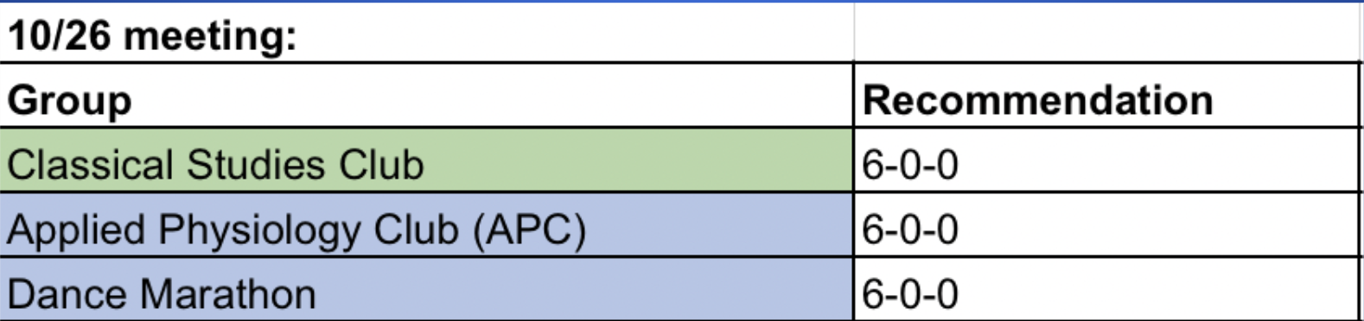
  - Recommended to approve all the following
  - Motion to see in block
    - Approved
  - Motion to approve in block
    - Approved
- Officer Report - President
  - Outdoor Seating
    - March 18th plan finish date
- Officer Report - Vice President
  - Survey about counseling
    - Difficulty with scheduling
  - Events: Hope Show
- Membership Chair Lugo
  - SBO candidates required to have been in the chamber the year prior
  - Running mate conversation: President and VP
  - No monetary compensation or items of value for campaign favors
  - Clarification that candidates are responsible for the actions of their campaign representatives
  - 72 hours to remove campaign materials
  - Streamlined requirements of who can run and vote for Asian Pacific Islander, First Gen and International Senator.
  - Vacancy Specifics: Application screening process, rubric, DEI committee chair given discretion to appoint an interviewer for special interest roles
  - Standard of Proof
  - Streamlining Code
- Officer Report - Parliamentarian Leathers
  - Motion to vote
  - Meeting with Ashley Fitzpatrick
    - Conversation regarding ADpi
- Advisor Report
  - IGNITE National
    - Political women next Thursday November 16th
- DEI committee report
  - Coco movie night
  - First Gen fest
- Special Interest Senators report
  - Ibanez - working with SHIP, HOlA, Hilltop Lulac and Spanish Club
  - Howard - Working with Jude looking at election Code special election process
  - Strickland - Scholarship committee, Milvet Luchin, Space Force Flag
  - Kim - Beyond Finance, Transportation services working with Dart SMU council
  - Harms - working on First Gen Scholarship, Book and Tech Fund renamed Book and Course Material Fund, Also First Gen Library
  - Robb - Next week International Education Week doing a tabling event, and working on fashion Show, also a lot of employment focus as well.
  - Hill - Helping with LGBTQ center
  - Dickinson - SRBOT for athletics also works with SAAC
- Announcements
  - Next week packed agenda
  - Senator Grey Birthday
- Adjournment

