110th Student Senate Meeting Minutes 11/28/2023

In Attendance: 110th Student Senate Chamber, Advisory Murphy,
- Roll Call
- Approval of the agenda
  - Approved
- Speakers Podium - The Narcan Project
  - Organization behind Narcan
  - Interest form sent if people are interested
- Finance Committee New Business
  - Motion to see the new business as old business
    - Approved
- Finance Committee Old Business
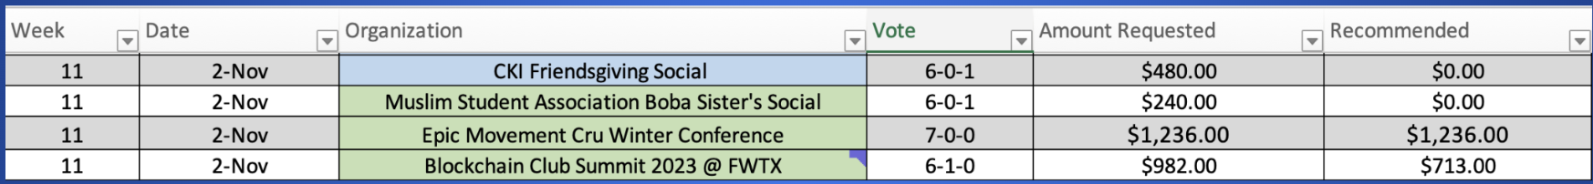
  - Motion to see old business as block
    - Approved
  - Motion to approve
    - Approved
- Finance Budget Retreat update
    - $953,799 requested
    - $150,000 budgeted
  - Motion to approve finance committee recommendations
    - Approved
  - Motion to approve
    - Approved
- Orgs New Business
  - Motion to see the new business as old business
    - Approved
- Orgs Old Business

  - Recommended to approve all the following
  - Motion to approve in block
    - Approved
- Officer Report - President
  - Finance Chair Nomination
    - Senator Chen
    - Motion to approve
      - Approved
  - New and Old business Process
  - Scholarship Emergency Meeting
- S-110-P04
  - Discussion for and against all
  - 44-0-3
- Membership Chair Lugo
  - SBO candidates required to have been in the chamber the year prior
    - Motion to reconsider
      - Denied
  - Running mate conversation: President and VP
    - Motion to reconsider
      - Denied
  - No monetary compensation or items of value for campaign favors
    - No motion to reconsider
  - Clarification that candidates are responsible for the actions of their campaign representatives
    - No motion to reconsider
  - Vacancy Specifics: Application screening process, rubric, DEI committee chair given discretion to appoint an interviewer for special interest roles
    - No motion to reconsider
  - Discretion should be afforded to the membership to determine whether an action is prohibited under the election code
    - Motion call to question
      - Approved
    - Senator Thomas for
    - Senator Hall against
    - Vote: 44-1-1
      - Approved
  - 72 hours to remove campaign materials
    - Motion call to question
      - Approved
    - Vote: 46-0-1
      - Approved
  - Streamlined requirements of who can run and vote for Asian Pacific Islander, First Gen and International Senator.
    - Motion call to question
      - Approved
    - Vote: 46-0-1
      - Approved
  - Standard of proof used in election complaint hearings should be based on a preponderance of the evidence
    - Motion call to question
      - Approved
    - Vote: 46-0-1
      - Approved
- Senatorial Report - Cox Senators
  - Cox building done in May
    - Places for organizations
  - Cox advisors are rough
  - Modernize marketing program
  - Acceptance rate is going in the right directions
- Senatorial Report - Simmons Senators
  - Working on separating APSM
  - Student panels and alumni panels
  - Doing more tours in simmons
- Senatorial Report - Dedman Senators
  - Accessibility issues
  - Hiring process
  - Restarting mentorship program
- Senatorial Report - Project Senators
  - Senator Thomas - night access
  - Tamal - whiteboard
  - Markus - SMU grievance form
  - Ian - Outdoor directories
  - Strickland - events for veterans
- Senatorial Discussion
  - Ian met with intramural people director of Dedman Rec
  - Senator Mellor - Dining council question
  - President alarcon is playing with playdoh
- Announcements
  - Project senators send updates to emerson
- Adjournment

